Name: Bhumika Kushwaha
THE SPARK FOUNDATION – DATA SCIENCE AND BUSINESS ANALYTICS
Task 1: Retail Superstore
A retail sale occurs when a business sells a product or service to an individual consumer for his or her use. The transaction itself can occur through several different sales channels, such as online, in a brick-and-mortar storefront, through direct sales, or through direct mail. The aspect of the sale that qualifies it as a retail transaction is that the end user is the buyer.
'Exploratory Data Analysis' on dataset 'SampleSuperstore' :
Exploratory Data Analysis refers to the critical process of performing initial investigations on data to discover patterns, spot anomalies, test hypothesess, and check assumptions with the help of summary statistics and graphical representations.
Problem Statement:
- As a business manager try to find out weak areas where you can work to make a profit.
- What all business problems you can drive by exploring the data

So, we're going to import the necessary Python libraries:
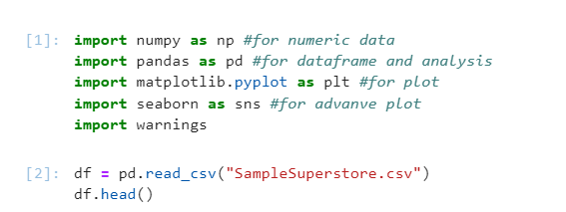
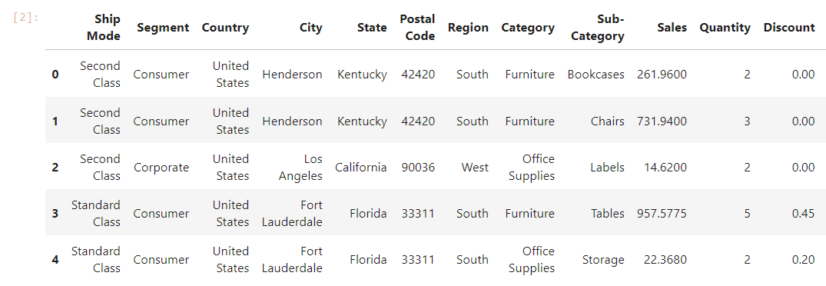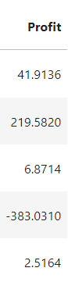

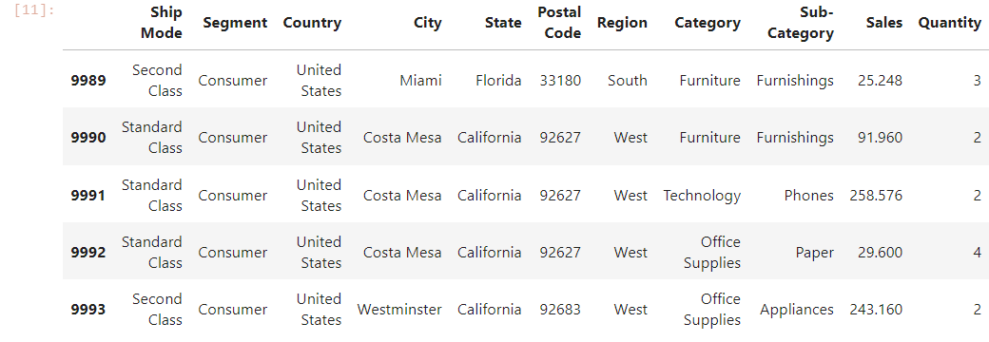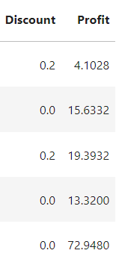
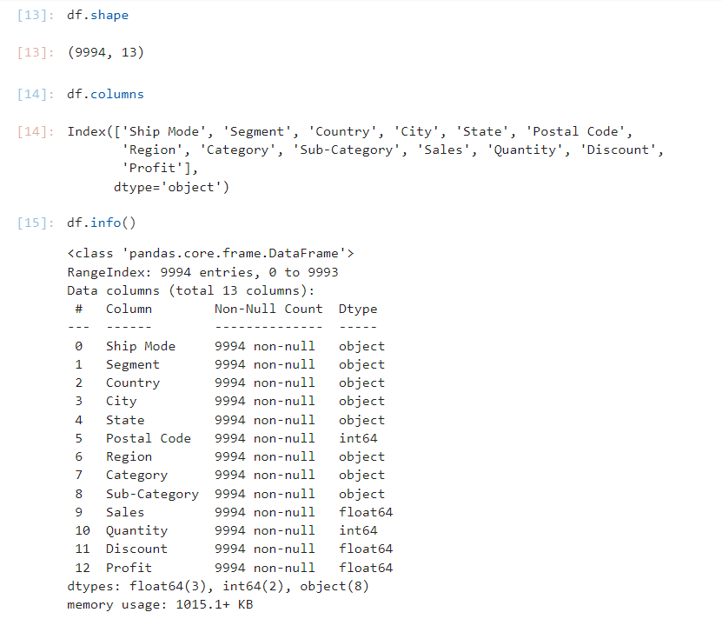
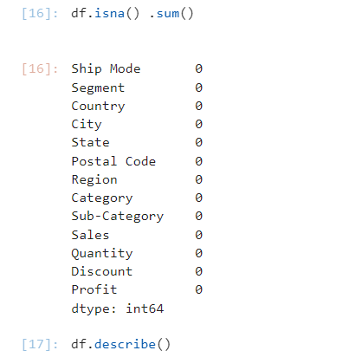
#There is no null value in data set

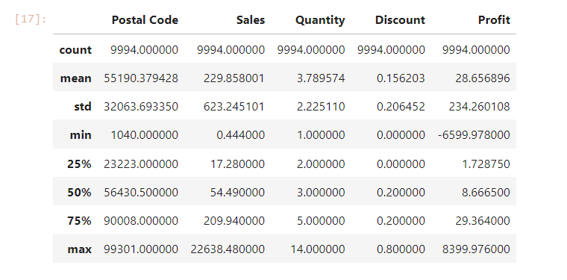

Observation:
- In total, Retail Superstore makes an average profit of 28.65 per order.
- The maximum loss will be about 6599.97 and the profit is approximately 8399.97.
- The average superstore sells around 229 items per order.
- There's a Max discount of about 80 percent offered by the superstore.

Let's take a closer look at our analysis, and see what we have to say:
Univariate Analysis:
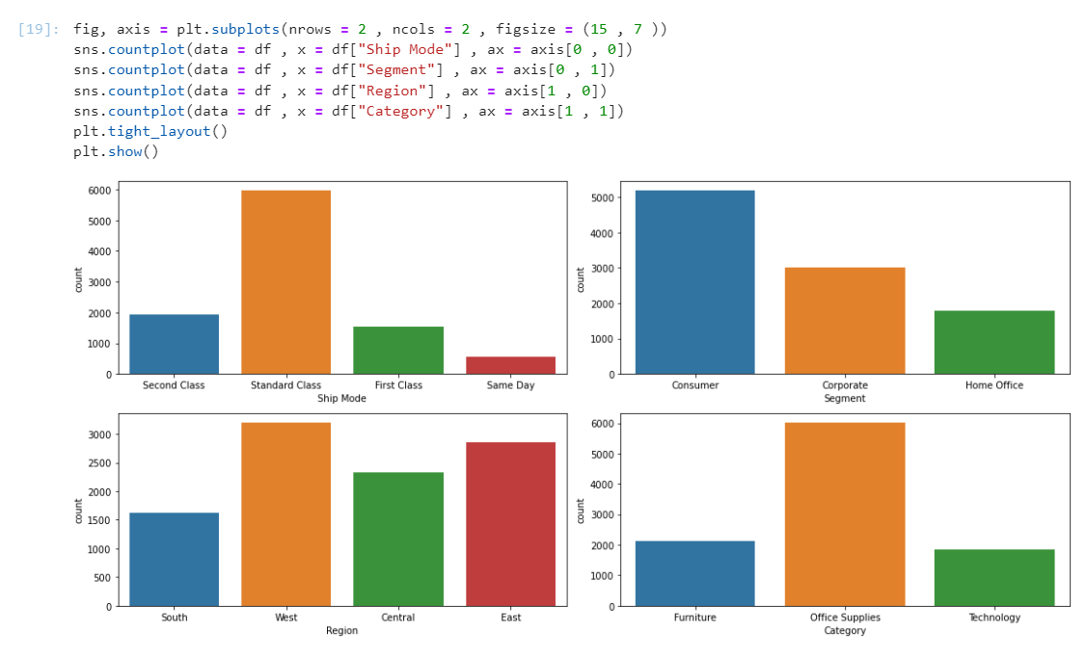

Observation:
- Most of the orders have ship mode as Standard Class and least for the Same Day.
- Majority of the orders are Consumer segment while the least is for the home office.
- Highest number of orders are from the West and East Region while the least are from the South.
- Majority the category of orders are for office supplies as compared to other categories.
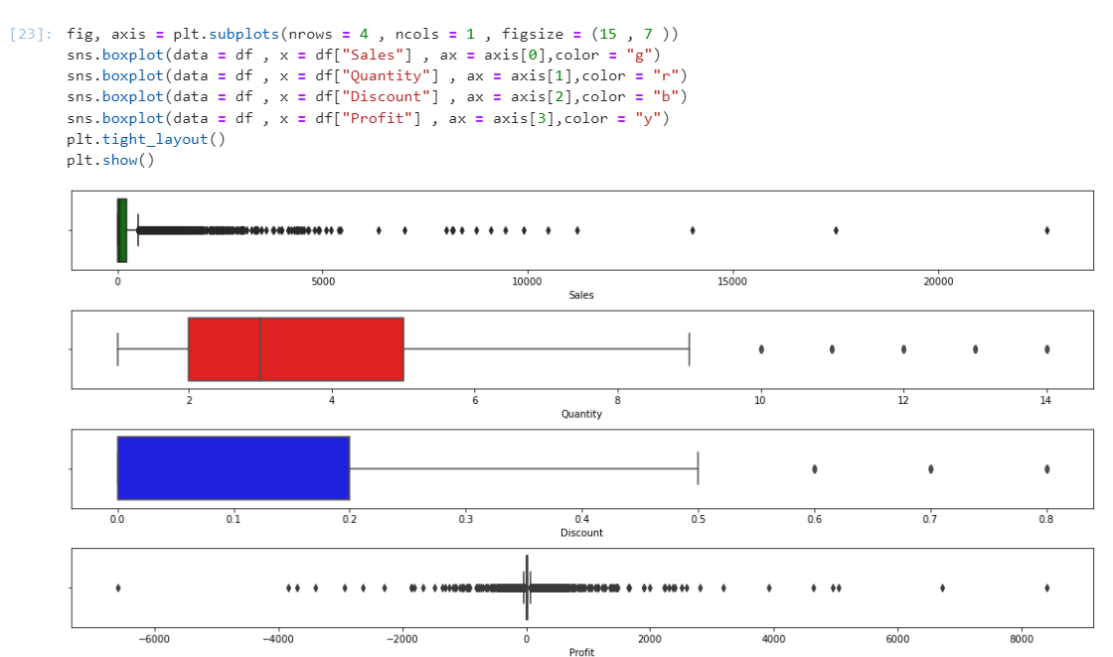

OBSERVATIONS:
- There are many outliers in the Sales attribute and all of them are on the positive side i.e. higher side.
- Majority of the Quantity lies between 3 to 9 orders with some outliers on the higher side.
- Discount majorly ranges from 0 to 50% with 60%,70%, and 80% as an outlier.
- Profit has the highest number of outliers and seems to incur losses too.

Bi-Variate Analysis
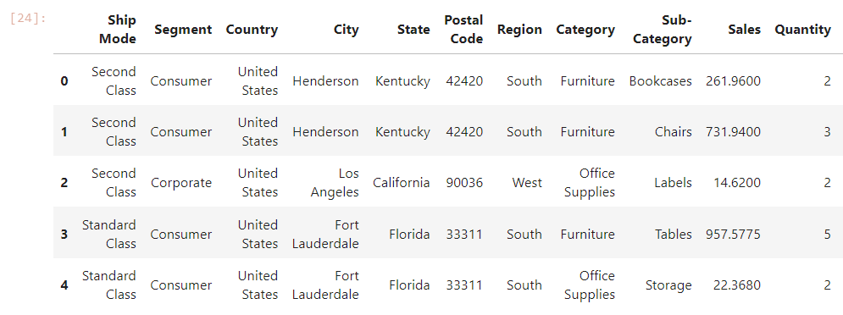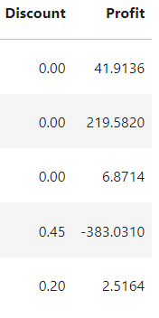
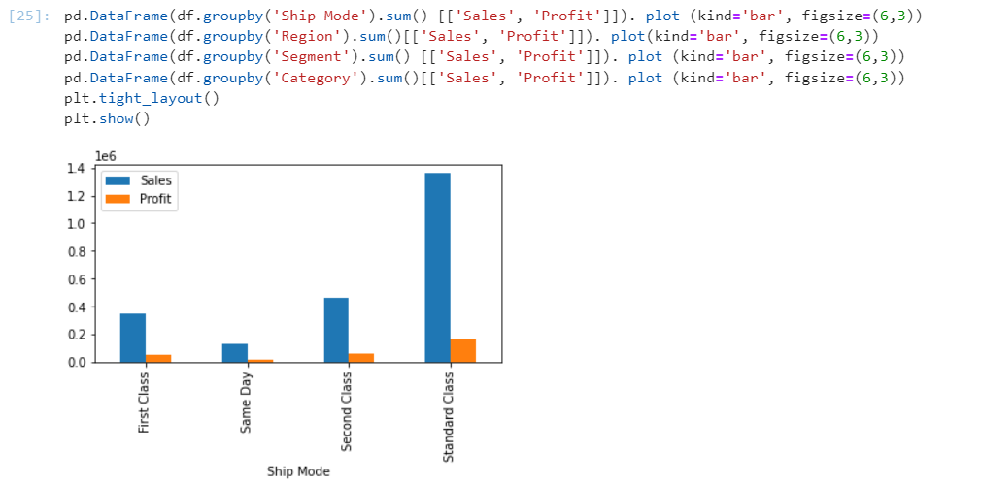
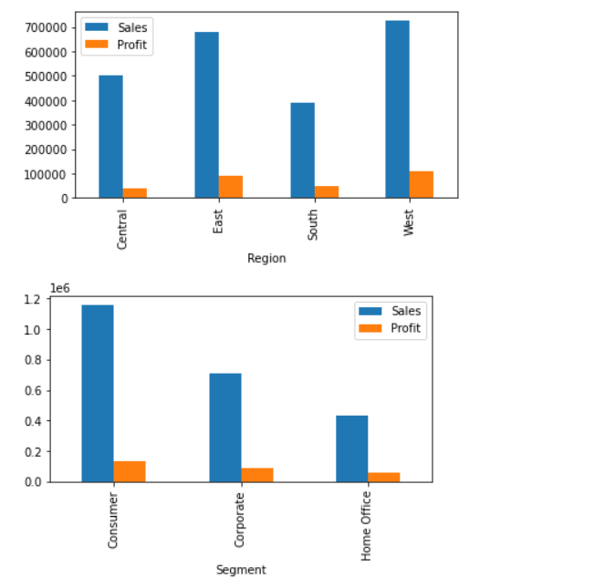
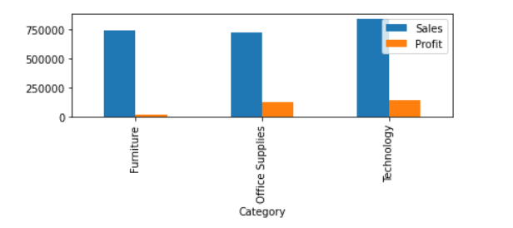
OBSERVATIONS:
- The profit far or less as compared to the sales that have been made through Standard class ship mode that infers that some good amounts of losses have been incurred
- The sales are lowest in the south region.
- profit in the central region is not upto the mark
- Sales and Prots both are highest for the consumer segment and lowest for the home office

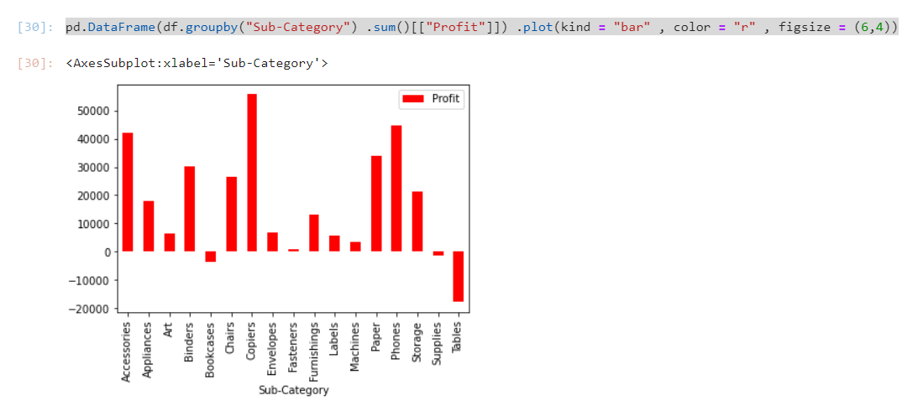
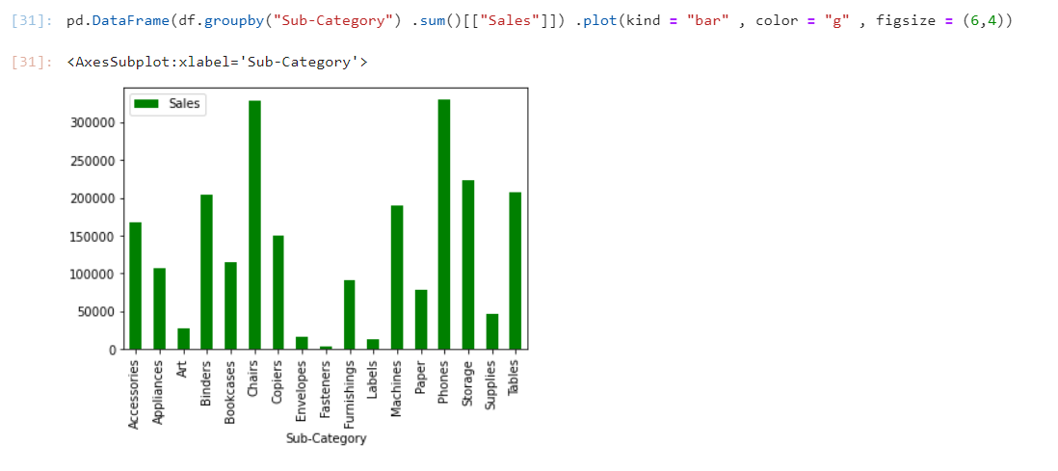
Observation:
- Chairs and Phones are the highest-selling subcategory while Art, Envelopes, and Labels have the least sales

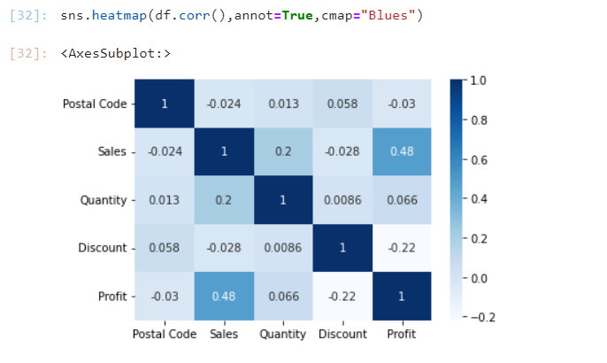
By Heatmap we confirm two obvious logical arguments:
- Discount is negatively correlated with profit.
- Sales have a strong positive correlation with profit.

Impact of Discount on Sales:
- From the heatmap we got an interesting observation. The discount should have a positive impact on sales but inferring it seems to not have any great impact on Sales it is having a negative correlation that is a major problem.

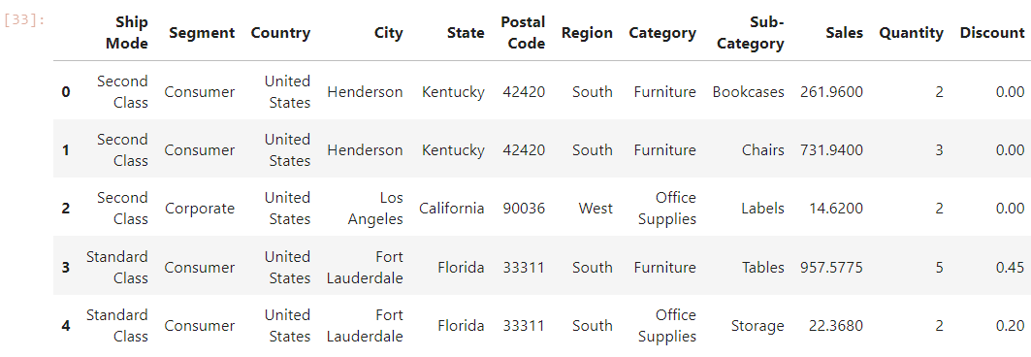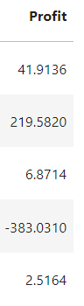

Top and Bottom Position of State in Terms of Profit & Sales:
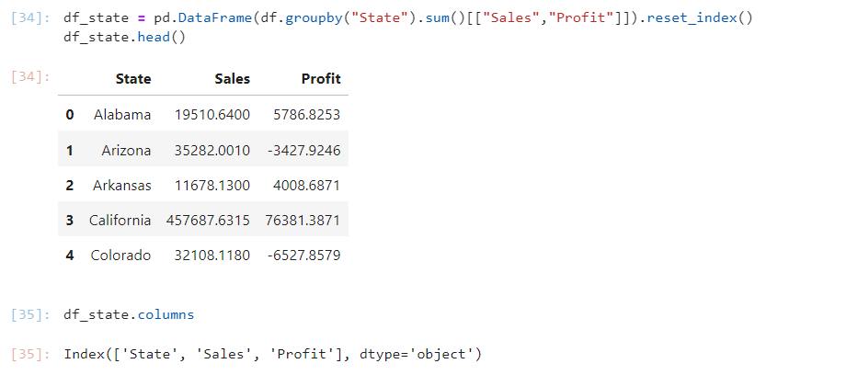
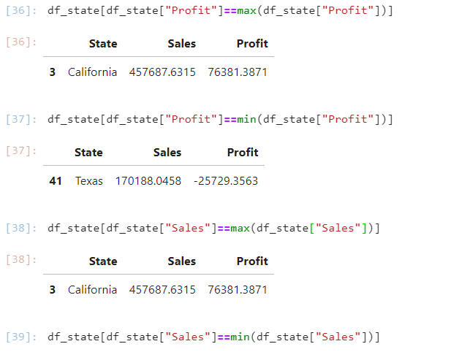
California has highest profit of 76381
Texas with loss of 25729
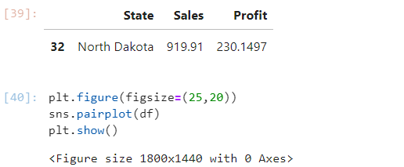
California with highest sale of 457687.
North Dakota with loss of 919
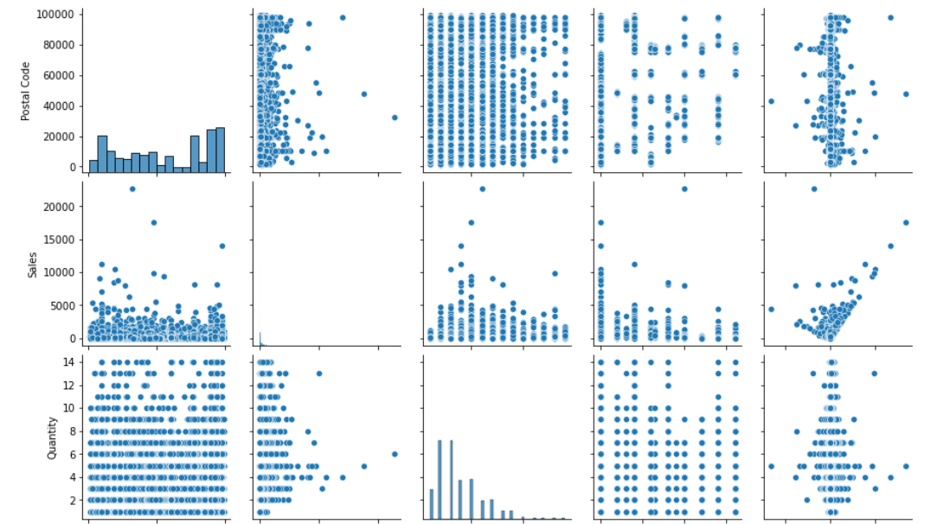
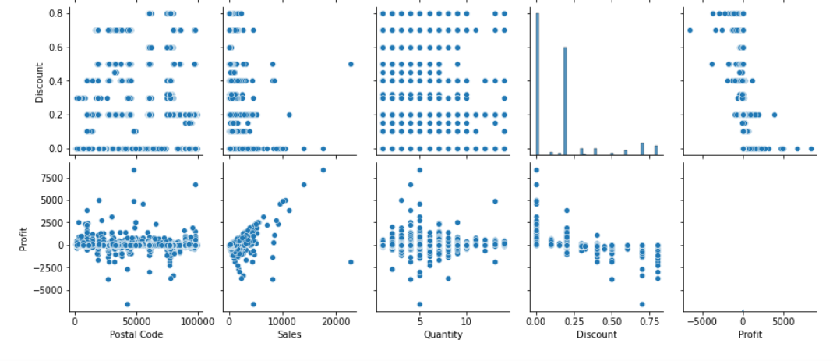
RECOMMENDATIONS:
- Superstores should concentrate more on improving sales in these regions by increasing discounts on specific products that have a higher demand for this region and also upgrading their delivery capacities to compete with each other.
- As the category of furniture provides the least profit, in particular Tables sub-categories that suffer large losses, we will have to reduce sales or discounts on it.
- To improve these conditions more special discount offers should be made available for a shorter period, to increase the sales of Fasteners, envelopes, Labels, and Art.
- To give sales a boost. It is observed that the discount hurts sales, which is a major problem, and it is necessary to restructure the calculation of the amount of the discount on different products, such as in-demand products with a moderate discount, while heavy discounts should be provided for less-sold products.

***************************************************************************

